Title or Task: | AIT2a Task 2 : Produce a Web Page for Information Technology

Description:

Files Required
Suitable for Classes: | Applied Information Technology
Area: | Technology & Enterprise
Teacher: | Mr Peter Faulks
Marks: | Worth: | Weighting:

Date Due:

Task Brief:
Outcomes: | Produce


Items highlighted in yellow are tasks for you to complete
Items in Purple are help tips

Web Design Worksheet

You are to produce a web page based on current technology. This can include mobile phones, flat screen TV, video formats or hard drive movies, mp3 players or whatever you feel influences trends in technological items.

Use the following booklet as a template you do not have to use every page but you should produce a logical plan of your proposal supported by draft designs and ideas. In Task 3 you will actually make your web page!
(Group to complete this booklet) the teacher will view this as a print out or from your files on your computer – each stage MUST be completed by group and checked by the teacher)

Web Page Project Title

Compiled By (include names and position)

The contents of this Web Design Worksheet have been set out according to the Technology Process –which involves Investigating, Devising, Producing and Evaluating. By completing it in detail you will be demonstrating some of the fundamental requirements of the Student Outcomes.

Note: Your final achievement level will be a combination of your Investigation, Devising, Production and Evaluation NOT just the final product.

Investigating

( Identify the requirements, issues, values, needs and opportunities associated with this task)

Identify the:
- Topic
- Target audiences characteristics
- Key design considerations

Devising (Describe your ideas, alternatives and opportunities)

Produce a:

- Time Plan
- Content Map
- Hierarchy Structure Chart
- Navigation Map
- Home & Template Screen Layout plan
- Prototype Storyboard (Splash page screen layout design)
- User Documentation
- Resource Records / Bibliography

Producing (products, processes, systems, services, environments)

Identify and justify:

- Selected software tools
- Production techniques and sequence

Evaluating (intentions, plans, actions, consequences)

Web Design Worksheet Proposal

1. Technology to be developed
(What are you trying to produce, describe your web site?)

➢[Type your response here.]

2. Key Target Audience Characteristics:
(eg. Age; Gender; Interests; Pre-requisite Knowledge; Motivations; Language, Wealth, etc.)

➢[Type your response here.]

3. Key Design Features
(eg. What key features will you build into your technology and why.)

➢[Type your response here.]

4. Societal / Environmental Considerations
(eg. What societal or environmental factors might effect the development of your technology and why? – laws, boundaries, beliefs, conservation, health, employment, etc)

➢[Type your response here.]

5. Other Circumstances Affecting Production Techniques
(e.g. What other factors might effect the development of your technology and why? E.g. Mass Production Techniques, Marketing, Delivery, Budget, Time availability)

➢[Type your response here.]

Web Design Worksheet Annotated Web Pages

Annotate two web pages looking at layout, SPARC, colour, ease of navigation, ease of use plus any other critical analysis etc.

Page 1

Page 2

Web Design Worksheet Journal

13. Production Techniques and Sequence
(Throughout the construction of your product you should keep a daily LEARNING LOG. Use this to indicate specific production techniques and the sequence of events ie. Did you follow your initial time plan?)

14. Daily Learning Log (Who did what?)
(Make a comment each day about your learning experiences, problems and solutions. This can be using the electronic learning log. A sample is shown below – make more rows as required)

Person 1
 | Name
Day | Date | What I Did | Problems | Solutions
 |  | add more (Right mouse click – insert rows below)

Person 2
 | Name
Day | Date | What I Did | Problems | Solutions
 |  | add more

Student: Task: Teacher: Mr Faulks

Journal or Time Planner

 |  | Mark when done
No. of Lessons |  | 1 | 2 | 3 | 4 | 5 | 6 | 7 | 8 | 9 | 10 | 11 | 12 | 13 | 14 | 15 | 16 | 17 | 18 | 19 | 20 | 21 | 22 | 23 | 24 | 25 | 26 | 27 | 28
Students Initials & Task | Day/Date
Tasks / Activities Tick when done
Have your teacher sign off on this document
prior to starting your task construction.
Signed

Web Design Worksheet Content Map

5. Content Map
Links =

TOPIC

Topic

Web Design Worksheet Sample (change to suit) Hierarchy
Fill in the pages add links and structure your site

Splash Page (page 1)
- Welcome
- Our Location
- News & Events
- Stock Catalogue
- Promotions
- Services
- Sign Our Guest Book
- About Us
- Copyright
6. Hierarchy Structure Chart

Page 1

These are hyperlinks
Web Design Worksheet
ONLY WHEN MAKING A WEBSITE
Files & Folders

7. Navigation Plan / Folder Structure
(Demonstrate that you have thought about the structure and appearance of your product)

SAMPLE ONLY

topic name
eg.
sub_topic 1
eg.
images
home.htm

ONLY WHEN MAKING CREATING THE
WEBSITE
Screen shot - Print screen of your site files and paste it here

Web Design Worksheet Draft Sketches of Main Screens

8. Screen Layout Plan
(Draw the basic screen layout demonstrating sound design principles. e.g SPARC)

Home Screen

Screen Template
(This shows the position of repeating elements ONLY)

Web Design Worksheet STORYBOARD

9. Storyboard
(Where appropriate you may need to draw a layout design for other key screens indicating the exact content and design features such as Graphics, Sound, Animation, Colour etc.
Continue onto a separate page as necessary)

Key Features:

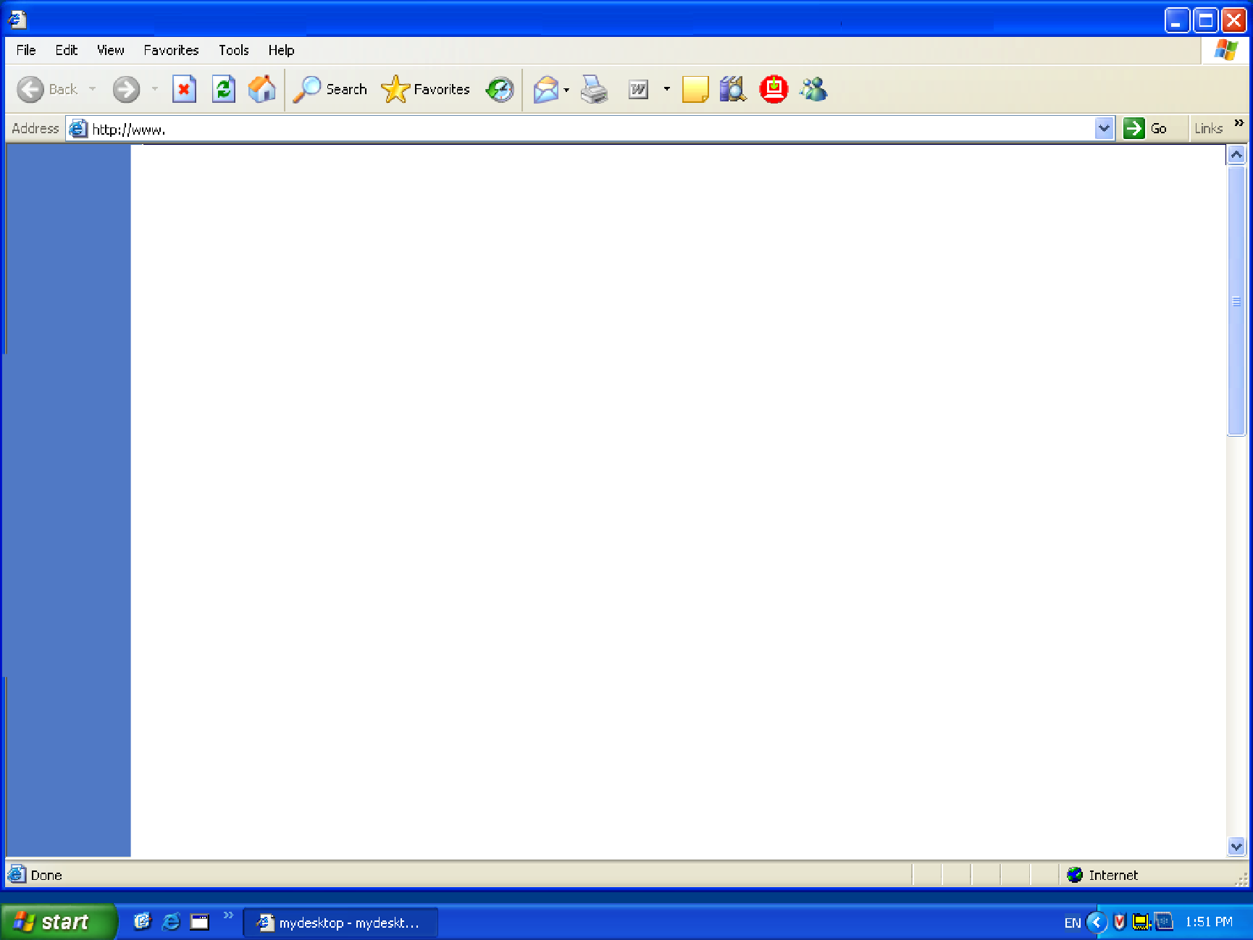

Key Features:

Key Features:

Web Design Worksheet Evaluation Sheet

10. What did you do to plan this web page
(What support information will your target audience need to effectively use your product?)

details:

➢[Type your response here.]

Have you provided On-screen Help how = details:

➢[Type your response here.]

11. Resource Record - Bibliography
(What resources have you or do you intend to use to create your product? You should have at least one from each of the following categories)

People: (Name; Position; How found)

1.

2.

Electronic Resources: (Web Sites, CD-ROMs, On-screen Help, Tutorials, Videos etc)

add more lines

1.

2.

3.

Non-Electronic Resources: (Books, Magazines, Newspapers, etc)

1.

2.

3.

Web Design Worksheet Evaluation

12. Selected Software Tools
(What software did you use to create your product. What features of the software made it particularly suitable for the way you used it?)

- Program:

Reason for use:

- Program:

Reason for use:

Task Evaluation
Consider your task carefully and critically evaluate your work by answering the following questions.

1. What was the purpose of your task?
__________________________________________________
__________________________________________________

2. Who was your intended audience of your newsreader background?
__________________________________________________

3. How well do you think your design suits the intended audience?
o  Very well | o  Quite well | o  Not sure | o  Could be improved | o  Audience not considered in the design

4. Have you been able to test your design on someone from your intended audience group?
What was their reaction?
__________________________________________________
__________________________________________________

5. How many samples were you able to view to help you investigate your design?
o  None | o  1 or 2 | o  About 5 | o  Between  5 and 10 | o  More than 10

6. How did you decide which software to use for your background?
o  I produced several versions in different software and chose the best | o  I did some drafts in a couple of applications and chose the best one to complete it in | o  I began using one application and swapped to another when my skill levels increased | o  I only used one of the suggested applications | o  I only tried word processing software

7. How original was your design?
o  I copied a design I had seen elsewhere | o  I copied a design and changed the colouring and shapes | o  I used a variety of designs and combined different aspects of them | o  I used a variety of ideas as inspiration and then developed my design | o  Completely original

8. Did you produce and keep draft copies of your background and your written response?
o  Yes, my pencil and paper drafts are in my hardcopy portfolio and my digital copies are in my electronic portfolio | o  Yes but only a digital draft version | o  Yes but I only kept a hardcopy draft | o  Yes I did but I didn’t keep any copies | o  No, only a final copy

9. Are you happy with your image manipulation skills at this stage?
o Yes o No
Explain
__________________________________________________
__________________________________________________

10. Would you like to develop your skills in image manipulation further since completing this task?
o Yes o No

11. Did you find any restrictions to your ability to manipulate your images?
_____________________________________________
_____________________________________________

12. Did you check your task for spelling and grammar mistakes?
o Yes o No

Why / Why not?
_____________________________________________
_____________________________________________

13. How did you feel about your time management for Task 1?
o  I need a lot more time to finish my event item properly | o  I spent more time than suggested in preparing my event item | o  It took me about the same time suggested in the course to complete my event item | o  I was able to work quite quickly and had some time to spare | o  I worked very quickly and was able to spend time refining my item through learning more application tools
14. Have another look at the Scenario and the Task 1 Explained. Do you believe this item meets the requirements of the task? Explain
_____________________________________________
_____________________________________________
_____________________________________________

Save your evaluations as (your initials)_task1_eval into your Week 10 portfolio.
Send a copy to me at the end of the week.

- Program:

Reason for use:

- Program:

Reason for use:

- Rate yourself in the boxes below on the following criteria

AIT (Level 4, 5, 6 or 7)
- For each box  Rate Your score in each based on the following: | Satisfactory High Very High
 | 4 | 5 | 6 | 7

                - Type your score here

Ability to locate information & research without any assistance
Shows initiative
Leadership/Planning Qualities
Application to the task
Time Management
Works without any ‘nagging’ from the teacher

- Did you personally enjoy investigation of your task?

➢[Type your response here.]

- Yes / No Why

- What are some things you liked / disliked about this task?

Present this worksheet for each phase starting with your proposal…

If as a printed copy - it will be regularly returned to you during the task for updating.
or
Electronically checked on your computer.

- Proposal
- Draft Ideas –hierarchy
- Storyboard
- Journal
- Evaluation

